**KA2 - Cooperation for innovation and the exchange of good practices**

**KA204 - Strategic Partnerships for adult education**

**Active Strategies for Prevention and Handling Sexual Harassment Incidents (ASTRAPI)**

**2019-1-CY01-KA204-058414**

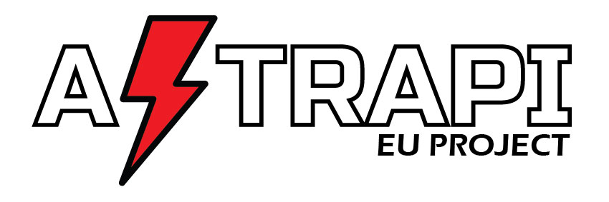

**Training Handbook to prevent and handle sexual harassment at work**

**Prepared by**

**Gender Five Plus and**

**Panteion University – Centre for Gender Studies**

**November 2020**

.

This project has been funded with support from the European Commission. This publication reflects the views only of the author, and the Commission cannot be held responsible for any use which may be made of the information contained therein.

Table of Contents

Introduction 9

Who is this training handbook for? 9

Content 9

How to use it? 9

Key definitions 10

Module 1 - Introduction to sexual harassment 12

☞ Duration: 5 hours 12

☞ Learning objectives 12

☞ Aim 12

☞ Target group 12

☞ Trainer’s preparation 12

☞ Material 13

Activity 1. What is sexual harassment in the workplace? 13

Duration: 2 hours 13

☞ Aims 13

☞ Key points 13

☞ Trainer’s preparation 13

☞ Proposed sequence and exercises 14

Present the definition of “World of work” from Article 3 of the C190 - Violence and Harassment Convention, 2019 (No. 190) 16

Activity 2. Legal and policy framework on sexual harassment 17

Duration: 1,5 hours 17

☞ Aims 17

☞ Key points 17

☞ Trainer’s preparation 17

☞ Proposed sequence and exercises 17

Activity 3. A comprehensive approach towards ending sexual harassment in the workplace 19

Duration: 1,5 hours 19

☞ Aim 19

☞ Key points 19

☞ Trainer’s preparation 19

☞ Proposed sequence and exercises 20

Module 2 - Tackling gender inequalities, discrimination and social norms 21

☞ Duration: 2 to 3 hours 21

☞ Learning objectives 21

☞ Aim 21

☞ Content 21

☞ Target groups 21

☞ Trainer’s preparation 21

☞ Material 21

Activity 1. Understanding the basic concepts related to gender equality 22

Duration: 1 hour 22

☞ Aim 22

☞ Key aspects 22

☞ Target group 22

☞ Trainer’s preparation 23

☞ Material 23

☞ Proposed sequence and exercises 23

Activity 2. Inequalities and discrimination 26

Duration: 1,5 hours 26

☞ Aim 26

☞ Key aspects 26

☞ Target groups 26

☞ Trainer’s preparation 26

☞ Material 27

☞ Proposed sequence and exercises 27

Module 3 – Comprehensive prevention activities in the workplace: base line analysis 30

Duration: 3 hours 30

☞ Learning objectives: 30

☞ Aim 30

☞ Key aspects 30

☞ Target groups 31

☞ Trainer’s preparation 31

☞ Material 31

☞ Proposed sequence and exercises 32

Module 4 – Workplace policies, procedures and practices 34

Duration: 4 hours 34

☞ Learning objectives 34

☞ Aim 35

☞ Key aspects 35

☞ Target groups 35

☞ Trainer’s preparations 35

☞ Material 35

☞ Proposed sequence and exercises 36

Module 5: Effective complaints procedures centred on support of victims 39

Duration: 4 hours 39

☞ Learning objectives 39

☞ Aim 39

☞ Key aspects 39

☞ Target group 39

☞ Trainer’s preparation 39

☞ Material 40

☞ Proposed sequence and exercises 40

Module 6: Active bystanders approaches 44

Duration: 2 to 3 hours 44

☞ Learning objectives 44

☞ Aim 44

☞ Key aspects 44

☞ Target group 44

☞ Trainer’s preparation 45

☞ Material 45

☞ Proposed sequence and exercises 45

Practicalities - designing a training course on how to prevent and handle sexual harassment in the world of work 48

1. Conditions for an effective training 48

2. Define your target group: 48

3. Framing your training: 48

4. Learning objectives: 48

5. Methodology of the training and set-up 49

6. Duration/format: 49

7. Drafting a training script and preparing material 50

8. Evaluating the training 50

Annexe – list of useful information to gather 52

# Introduction

## Who is this training handbook for?

* The primary target group is trainers who are familiar with the issue of sexual harassment in the world of work and who have experience in participatory training. They are assumed to master basic training skills, and to have a fair understanding of gender issues in general and sexual harassment (SH) in particular.

Their audience (ultimate beneficiaries) will be a range of people occupying a variety of positions in the world of work (trade union reps, health and safety officers, managers, HR managers, staff members, et.al.), who are not necessarily knowledgeable about SH or even aware of the issue, or can express resistance about it.

* This handbook is designed to guide trainers to deliver training workshops on sexual harassment at work taking a transformative approach (as presented in the ASTRAPI toolkit).
* It offers the trainer guidance on how such a transformative approach can be taught to a range of different target groups. Trainers can follow the structure of the handbook when designing and delivering training, but the given structure is by no means binding. Depending on the purpose, length, or needs of target groups, individual modules can be delivered on their own or modules can be switched around. ***The guiding principle in delivering training is having FLEXIBILITY based on training needs.***

## Content

This handbook is based on the ASTRAPI European toolkit for effective implementation of policy to prevent and address sexual harassment in the world of work.  The handbook is conceived as a practical tool operationalizing the ASTRAPI toolkit, which outlines a transformative strategy to combat sexual harassment in the world of work whilst providing a wealth of theoretical information as well as policy examples.

The handbook focuses on helping the trainers to design a training which will empower their audience to act at their level. It is rooted in a feminist approach based on participatory learning, starting from the participants' experience and development of self-reflection. It aims at encouraging trainers to make use of their experience and expertise, considering the specific audience they will address and the context in which the training will take place. It also aims to strengthen trainers' skills by providing them with effective techniques that they may not be familiar with.

## How to use it?

This handbook presents in different modules how a comprehensive training on sexual harassment at work can be designed and delivered. It follows a sequence of learning and is conceived as a series of building blocks. However, trainers can also use part of it, choosing some modules to best suit the target groups’ needs, their familiarity with the issue and their position within the organisation (mandate), all of which are factors that will determine the content, the approach and length of the training.

It is divided into 6 modules which are in some cases further subdivided into learning sessions (activities). The last module is dedicated to the practicalities of organising training courses on sexual harassment.

Each module has its own duration, learning objectives, aims, key aspects and exercises to be organised to meet the learning objectives. Proposed methods for exercises under one activity can serve as inspirations for exercised in other modules.

The number of participants in the training should not exceed 25 persons.

Annexe 1 provides relevant information and data to be gathered to prepare the training material.

## Key definitions

This handbook should be used as a guide to deliver training on sexual harassment and is based on the ASTRAPI European toolkit for effective implementation of policy to prevent and handle sexual harassment in the world of work. The toolkit provides essential background material and definitions (see Glossary). The most important concepts that inform the training activities are also found hereunder:

**Active bystander / upstander** is someone who takes an active role to prevent and end sexual harassment by deciding to intervene when they witness inappropriate language, jokes or other sexually harassing conduct in the workplace.

**Bystander** is someone who passively witnesses sexism, sexual harassment or any forms of bullying, either in person or online.

**Gender:** socially constructed characteristics of women and men. If individuals or groups do not ‘fit’ established gender norms they may face stigma, discrimination and social exclusion. Gender is influenced by gender norms and relations, which include stereotypes, values, attitudes, assumptions and activities that society deems appropriate for women and men. These are not fixed roles and change over time, and from one society or culture to another.

**Gender-based violence and harassment** mean violence and harassment directed at persons because of their sex or gender or affecting persons of a particular sex or gender disproportionately and includes sexual harassment.

**Gender inequalities**

Legal, social and cultural situation in which sex and/or gender determine different rights and dignity for women and men, which are reflected in their unequal access to or enjoyment of rights, as well as the assumption of stereotyped social and cultural roles.

**Institutional sexism**

**Institutional sexism** refers to **gender discrimination** reflected in the policies and practices of organizations such as governments, corporations (workplaces), public **institutions** (schools, health care), and financial **institutions**.

**Intersectionality:** acknowledging and recognising the interplay of gender identity/inequalities and other forms of inequality (including racism, xenophobia; classism, ageism, homophobia and ableism). Kimberlé Crenshaw introduced the theory and idea that when it comes to thinking about how inequalities persist, categories like gender, race, and class are best understood as overlapping and mutually constitutive rather than isolated and distinct.

**Sex:** different biological and physiological characteristics of males and females[1], such as reproductive organs, chromosomes, hormones, genetic conditions etc. Sex defines whether a person is biologically male or female.

**Sexual harassment** is defined in EU Gender Equality Directives as a specific type of discrimination, “where any form of unwanted verbal, non-verbal, or physical conduct of a sexual nature occurs, with the purpose or effect of violating the dignity of a person, in particular when creating an intimidating, hostile, degrading, humiliating or offensive environment”. (Gender Goods and Services Directive, Art. 2 (d); Gender Equality Directive (recast), Art. 2 (1) (d)).

**World of work:** Article 3 of the ILO C. 190 Convention on violence and harassment provides that the Convention is applicable to violence and harassment in the world of work occurring in the course of, linked with or arising out of work:

* 1. in the workplace, including public and private spaces where they are a place of work;
  2. in places where the worker is paid, takes a rest break or a meal, or uses sanitary, washing and changing facilities;
  3. during work-related trips, travel, training, events or social activities;
  4. through work-related communications, including those enabled by information and communication technologies;
  5. in employer-provided accommodation; and
  6. when commuting to and from work.

For other definitions, please refer to the ASTRAPI toolkit Glossary

# Module 1 - Introduction to sexual harassment

#### ☞ Duration: 5 hours[2]

#### ☞ Learning objectives

* Understanding of sexual harassment as one type of gender-based violence, that entails a range of behaviours that should be addressed;
* Understanding where in the workplace, sexual harassment can be experienced;
* Familiarity with the legislative framework and policy instruments applicable to the context that applies to course participants;
* Understanding that tackling sexual harassment should be part of a comprehensive approach and the responsibility of every organisation
* Identifying the different elements of a transformative approach to fight sexual harassment.

#### ☞ Aim

* Awareness raising (session of half a day); clarifying and understanding the drivers of sexual harassment in the world of work and;
* . Developing a shared understanding of key equality concepts.☞ *Content*

1. What constitutes violence in the workplace?
2. What is the legal and policy framework regarding sexual harassment in the workplace?
3. What defines a comprehensive approach towards ending sexual harassment in the workplace?

#### ☞ Target group

* Workers in an organisation
* Trade union representatives and officers
* Managers (all levels)
* Human resources, equality, inclusion and diversity managers
* Health and safety officers

#### ☞ Trainer’s preparation

* Familiarise yourself with the legal framework applicable to the local set-up of your training.
* Check for availability of local data on sexual harassment in the world of work.   
  See European Union Agency for Fundamental Rights, (2014) Violence against women: an EU-wide survey. Main results report, accessible at <https://fra.europa.eu/en/publication/2014/violence-against-women-eu-wide-survey-main-results-report>, and EIGE Gender Equality Index : <https://eige.europa.eu/gender-equality-index/2019/violence>
* Prepare for individual biases and resistance based on stereotypical assumptions.

#### ☞ Material

* Cards (post-it type) of different colours.
* Brown paper, poster or pin boards.
* Tape to fix the cards (or pins).
* Black markers type Artline 70 (one for each participant).
* Flip chart paper.
* Colour markers for trainer (black, blue, red, green).
* Laptop/computer and a beamer.

## Activity 1. What is sexual harassment in the workplace?

#### Duration: 2 hours

#### ☞ Aims

* Stimulate discussion on types of behaviours constituting sexual harassment with participants who may have different views and personal experiences.
* Develop a deeper and shared understanding of what constitutes inappropriate sexist behaviour in the world of work.

#### ☞ Key points

Sexual harassment is a form of discrimination on the ground of sex[3]. It can include conduct based on quid pro quo (where a favour or advantage is granted and/or where sexual harassment is a condition of the job) and/or hostile work environment (actions or behaviours create an uncomfortable work environment). It is a form of gender-based violence that can impact any workers, although women are disproportionally directly affected and workers facing multiple forms of discrimination and vulnerability on the labour market are at greatest risk.

The world of work includes not only the space where work is actually performed but also the public and private spaces existing in the workplace, e.g. where a worker takes breaks or sanitary facilities, during work-related events and social activities, when commuting to work (see supra under key definitions).

Make sure that during this session participants also understand that sexual harassment includes:

* any unwelcome sexually determined behaviour by a superior or a colleague,
* any favour or advantage granted and/or where sexual harassment is a condition of the job,
* any type of conduct that creates an intimidating, hostile or humiliating working environment for the victim but also for co-workers.

#### ☞ Trainer’s preparation

* Prepare a slide with data (quantitative and/or qualitative) on sexual harassment in the world of work[4] and if available, in the specific organisation (e.g. number of complaints).
* Prepare title cards with forms of sexual harassment (verbal, non-verbal and physical forms of sexual harassment) and potential settings where it can happen in the world of work, (see supra under key definition, “world of work”).

#### ☞ Proposed sequence and exercises

**Step 1**: what type of behaviour are we talking about? (group discussion: 40 minutes)

* In plenary, ask participants to write on a card an example of behaviour that they see as sexual harassment in the work context. Give them 5 minutes. Collect cards and stick them on the wall (brown paper, or poster or pin board).
* Read them out aloud and ask participants for clarification if necessary. Address the whole group, avoid asking directly the person who wrote it.
* Organise the cards in clusters[5], for example verbal, non-verbal and physical forms of sexual harassment. Stick them to the board under two title cards (unwelcome sexually determined behaviour and conduct that creates an intimidating, hostile or humiliating working environment).
* Discuss with the participants, check that both aspects (quid pro quo and hostile environment) are covered. If not, use examples to check on a common understanding (e.g. a co-worker makes very negative comments about women, but the comments aren’t sexual in nature. Is this harassment?)

**Step 2**: introduce the idea of a continuum of violence (suggested time 20 minutes).

* Present a slide with the continuum of sexual harassment as below, emphasizing how inequalities and gender norms in the workplace contribute to different forms of sexual harassment.
* The continuum of sexual harassment table shows a range of sexual harassment behaviour that can take place in the world of work. It serves to highlight that violence will escalate in frequency and intensity over time. Please note that behaviours do not always occur in the order in which they are listed on the continuum. The severity of these behaviours should be only judge by the victim and not through the place it has on the table.

|  |  |  |  |  |  |
| --- | --- | --- | --- | --- | --- |
| **The continuum of sexual harassment** | | | | | |
| **Visual** | **Verbal** | **Written** | **Touching** | **Power** | **Force** |
| Leering, inappropriate staring, sexual gestures or sounds;  Displaying or circulating pornography, sexual pictures or cartoons, sexually explicit graffiti, or other sexual images (including online). | Rough and vulgar humour and gender- related verbal abuse, threats, or taunting;  Bragging about sexual prowess or spreading sexual rumours (including online). | Love poems and letters;  Obscene letters, notes, and invitations. | Patting, hugging, and brushing against a person's body;  Grabbing, pinching, caressing, and kissing;  Invading personal space, impeding or blocking movements. | Demanding dates or sexual favours;  Requiring a person to dress in a sexualized or gender-specific way;  Paternalistic behaviour based on gender. | Sexual assault and rape |

Source of the slide:

<https://www.academia.edu/30302477/The_Continuum_of_Sexual_Harassment_from_Sex_to_Gender_Discrimination>.

* Emphasise that inappropriate behaviour, which may be considered minor, is important to counteract; show that sexual harassment does not only concern women but also different minority groups such as LGBT+.
* Explain that the continuum can be understood as an escalation in violence. The right side of the table corresponds to less socially acceptable behaviours (scarcer). However, the 'category' of the abuse cannot give a measure of the harm inflicted to a victim, except for sexual assault and rape. The perception of gravity of the behaviour is subjective and everyone’s experience is different.  
  **The purpose is not** for participants to discuss what harm is caused, but to show that even behaviours considered as minor (typically sexist jokes) can contribute to an unfriendly and hostile environment and ultimately be sexual harassment.
* A hostile environment can contribute to behaviours regarded as 'normal', thereby facilitating an escalation.
* Wrap up by underlining that sexual harassment comprises a wide range of behaviours and that the perception of the victim / recipient IS the key in assessing what is unwelcome as well as the as the severity of the harm caused.

**Step 3**: settings of sexual harassment (suggested duration 30 minutes).

* Explain that after the discussion about types of behaviours constituting sexual harassment, we are now looking at occurrences of such behaviours in the “world of work” (potentially engaging the responsibility of the employer).

# Present the definition of “World of work” from Article 3 of the C190 - Violence and Harassment Convention, 2019 (No. 190)

* The said Convention is applicable:
  1. in the workplace, including public and private spaces where they are a place of work;
  2. in places where the worker is paid, takes a rest break or a meal, or uses sanitary, washing and changing facilities;
  3. during work-related trips, travel, training, events or social activities;
  4. through work-related communications, including those enabled by information and communication technologies;
  5. in employer-provided accommodation; and
  6. when commuting to and from work.
* Organise a buzz session[6] (in pairs): ask participants to discuss this definition and when and where sexual harassment can take place, considering situations and circumstances relevant to their own working environment (e.g. shift work, home working, contact with public, working alone, etc.).
* Hand out cards and ask them to write one idea per card. Ask the participants to be as precise as possible: for example, if not at one's own desk, but at a client's meeting, through emails, face to face, etc.
* After 5-10 minutes, ask participants to come and place their cards on a poster prepared with title of settings as referred in Article 3 of the ILO Convention.
* If there are no cards under one heading, discuss this briefly with participants to check its relevance to their specific organisation.

**Step 4:** (suggested duration 20 minutes).

* Finalise this introductory part by presenting data on sexual harassment pertaining to the country or at any other relevant level to underline that the issue is demonstrably and objectively real.
* Wrap-up linking the different types of behaviours comprised in the definition of sexual harassment with the different locations and contexts in which they can occur.

## Activity 2. Legal and policy framework on sexual harassment

#### Duration: 1,5 hours

#### ☞ Aims

* Stimulate reflection on current legal obligations, with a focus on who they identify as actors and how they support action.
* Inform on existing rights and procedures.

**🏱**This module is best suited for people who have some authority and the means to act.

#### ☞ Key points

It is important for participants to understand the purpose and be familiar with existing legal instruments. Legislation, at international, European, national and sometimes local level, have been adopted to combat sexual harassment. They provide a frame of reference regarding the responsibilities of different parties (in particular employers) as well as procedures to follow. The very existence of national, international legislative frameworks and/or collective agreements underscores the importance of the issue and can provide resources for actors such as employers or trade-union representatives to get inspiration and access good practice examples.

#### ☞ Trainer’s preparation

* Check section 1.2 of the Toolkit on legal and policy framework on sexual harassment at work and prepare a slide with references to International Convention, European and National legal framework (including collective agreement and internal regulation if any) containing provisions on sexual harassment.
* Country specific information can be found in *i.e.* legal experts reports published by the European Equality Law network (<https://www.equalitylaw.eu/downloads/5119-a-comparative-analysis-of-gender-equality-law-in-europe-2019-1-35-mb>).

#### ☞ Proposed sequence and exercises

**Step 1**: assessing the current knowledge of legally identified actors of existing legal instruments (suggested time: 45 minutes).

* Ask participants what are the current legal instruments applicable in case of sexual harassment? (international/European/national, laws/collective agreement/charter/code of conduct, etc). => Ask participants about the current legal instruments applicable in case of sexual harassment they are familiar with.
* Mark the answers down on a flip chart with a black marker.
* Present the slide with all potential instruments. Check with participants what is missing. Complete the flip chart using a blue marker.
* Ask participants what are the legal instruments they would rely on when action is necessary? Circle those with a green marker.
* Discuss in plenary: why are some legal instruments not used (e.g. they are more restrictive in their definition; they are not adapted to the organisation; etc.)? If participants agree that some of the missing ones (in blue) are important, circle them in green.

**Step 2**: How participants understand and make use of existing procedures? (suggested duration: 45 minutes)

* Ask participants to reflect individually on the current approach or procedure existing in their organisation to be followed when witnessing or being a victim of sexual harassment? (2 minutes). This is important to allow each participant to reflect on his/her own knowledge and experience.
* Then ask participants to answer the following questions[7] in subgroups of 4 to 5 people. Give them 10-15 minutes to answer the following questions:
  1. Where (contact person?) and how (reporting system?) do you report an incident?
  2. Where do you find information about what to do in case of sexual harassment?
* Ask each sub-group to note their answers on a flip chart.
* Each group reports to the plenary. Ask them to concentrate on similarities but also on alternative perspectives and approaches in their presentations.

**🏱**in a training workshop focusing on Module 1 and delivered in a specific organisation, answers to the two questions should be clearly presented and the procedures explained in a few slides.

## Activity 3. A comprehensive approach towards ending sexual harassment in the workplace

#### Duration: 1,5 hours

#### ☞ Aim

* Introduce the ASTRAPI transformative approach and its different elements;
* Develop an understanding that the effective implementation of policies requires a comprehensive (preventive and responsive) approach and that everyone has a role to play.

#### ☞ Key points

Challenging institutional sexism is the responsibility of each organisation. It means that the decision-makers within an organisation have the responsibility to counteract unequal gender norms, roles and relations. It also means addressing the subtle and systemic ways in which sexism runs through an organisation’s culture, policies, processes and structures.

The ASTRAPI project proposes a framework for a transformative approach to ending sexual harassment in the world of work, which includes eight elements operating in a virtuous circle (see illustration on next page).

1. The starting point of a transformative approach is an awareness of and a willingness to tackle gender inequalities, discrimination and social norms in the world of work.
2. The approach needs a strategy and an action plan to preventing sexual harassment in the workplace.
3. It requires the development of effective workplace policies and procedures, embedded in human resources management and social dialogue, with clear and robust procedures trusted by workers.
4. Effective complaints procedures are an essential part of a transformative approach. They should be centred on the victims needs and guarantee a supportive environment where workers feel safe to report sexual harassment.
5. Victims should be presented with effective solutions and support. They need to be listened to and their needs and concerns must be acted upon.
6. Bystanders should be trained and encouraged to report signs of sexual harassment (bystanders programmes) to prevent sexual harassment and provide better support for victims;
7. The approach should ensure that perpetrators are held accountable for their actions.
8. A final point is to ensure continuous awareness raising, training and workplace campaign to end sexual harassment.

#### ☞ Trainer’s preparation

* A slide with the different aspects of the transformative approach (see below).

Ending sexual harassment in the world of work

i) Tackling gender inequalities, discrimination and social norms

ii) Comprehensive prevention and risk assessment in the workplace

iii) Human resource policies, procedures and practices

iv) Effective complaints procedures

v) Support and remedies for victims/  
survivors

vi) Active bystander approaches

vii) Perpetrator accountability

viii) Raising awareness, training, workplace guidance and campaigns

*Fig 1: Transformative cycle to ending sexual harassment at work*

#### ☞ Proposed sequence and exercises

**Step 1** Identifying elements of a transformative approach (around 60 minutes)

* Divide participants in sub-groups of 4 to 5.
* Distribute cards, ask them to write one element of the transformative approach per card and to classify them in order of priority for their organization, or sector, etc according to set-up of the training). (15 minutes)
* Discuss in plenary the results of each group, highlighting commonalities and differences. (30 minutes)
* Present the slide with the diagram and explain briefly what all the elements refer to and how they build the comprehensive approach needed for the effective implementation of policies and how everyone has a role to play. (10 minutes)
* If relevant, explain where the training fits in the cycle and why. (5 minutes).

**Step 2** (suggested duration 20 minutes)

* Ask participants to reflect on one idea that they will take home from this module. (5 minutes)
* Ask them to share answers with the rest of the group. (15 minutes)

# Module 2 - Tackling gender inequalities, discrimination and social norms

#### ☞ Duration: 2 to 3 hours

#### ☞ Learning objectives

* Understanding the basic concepts related to gender equality.
* Understanding that inequalities, discrimination and social norms are prevalent in society and in an organization and should be addressed in view of ending sexual harassment.

#### ☞ Aim

* Show how social norms are constructing gender roles, gender relations and behaviours that underpin sexual harassment.

#### ☞ Content

1. Clarify basic concepts of gender and sex as fluid categories and intersectionality (multiple identities);
2. Contextualise sexual harassment, delving into gender norms and gender inequalities at work;
3. Explore how existing social norms (stereotypes, believes, behaviours and attitudes) in an organization can either support or undermine institutional sexism.

If your target group is not familiar with the concepts of gender, sex and intersectionality, start with Activity 1, if they already have a basic understanding, go directly to Activity 2.

#### ☞ Target groups

* Any worker in an organization
* Middle managers
* Trade union representatives
* Human resources and health and safety officers

#### ☞ Trainer’s preparation

* Compile data on gender (in)equality relevant for your audience (EIGE Index on Gender Equality (<https://eige.europa.eu/gender-equality-index/2019/violence>) or other gender equality index).

#### ☞ Material

* Cards (post-it type) of different colours.
* Brown paper, posters or pin boards.
* Tape or pins to fix the cards.
* Black markers type Artline 70 (one for each participant).
* Flip chart and paper.
* Colour markers for trainer (black, blue, red, green).
* Laptop/computer and beamer.

## Activity 1. Understanding the basic concepts related to gender equality

#### Duration: 1 hour

#### ☞ Aim

* Clarify the difference between sex and gender
* Introduce the concept of intersectionality.

#### ☞ Key aspects

At birth, based on biological features relating to sexual reproductive organes, individuals are given a 'sex', either 'male' or 'female'.[8] During our childhood we are taught the roles, behaviours and attributes that are considered appropriate for a woman or a man[9].

The term 'masculinity' refers to the roles, behaviours and attributes that are associated with men and considered appropriate for men. Likewise, 'femininity' refers to a society’s ideas about the roles, behaviours and attributes that are considered appropriate for women. Such social constructs about masculinity and femininity vary across time and space but inform our everyday understanding of the society we live in, including our view of what are 'natural' qualities and competences which arguably determine positions in society. For example, professions and sectors in the labour market can be associated with a gender on the basis of supposedly 'natural' characteristics. Typically, leadership competences will be 'naturally' attributed to men, while caring responsibilities will be associated with women.

Sex and gender are often used interchangeably, even in policy papers, but they are not synonyms. The value of using the concept of gender, a social construct, as an analytical tool is that it allows to unravel social norms. should be explained in view of engaging in a comprehensive approach towards ending sexual harassment.

Finally, as the experience of sexual harassment and sexist behaviour can vary according to other variables such as age, supposed origin, class, etc., a short introduction to intersectionality is important.

**🏱**Be aware of the limits of an experience-based approach. Participants may attempt to use their personal experience to marginalise gender knowledge and research. Systematically refer to international research, verified data and indexes as well as political commitments which demonstrate an evidence-based approach to the analysis of gender norms and inequalities.

#### ☞ Target group

* Any worker in an organization
* Middle managers
* Trade union representatives
* Human resources and health and safety officers

#### ☞ Trainer’s preparation

* A slide with key data on gender inequalities in the organization if available or otherwise in the sector, region or country.
* A slide with the ‘Genderbread Person’ (see below)
* A slide illustrating the different aspects of identities (intersectionality).

#### ☞ Material

* Two flip charts for the drawing.
* Cards for buzz sessions[10].

#### ☞ Proposed sequence and exercises

**Step 1**: Social gender norms (suggested duration 30 minutes)

* Ask four persons, ideally two women and two men to draw a 'typical' woman and a 'typical' man (e.g. prompt: someone you would see in the street) and give them ten minutes. The other participants are watching.
* After 10 minutes, ask the room which elements of the drawing show that it is a man. Circle the elements in black. Do the same for the drawing of a woman. Then ask participants which of these differences are based on biological differences, and circle those in green. Mark the other differences in red. Finally, ask participants where the other differences (in black) come from (see illustration below).
* Explain the concept of gender and sex. It is important to state that while we can easily recognise social norms relating to dress code or other elements of appearance, it is less the case for other aspects such as supposed ‘natural’ competences, appropriate behaviours, etc. It is important to acknowledge how social norms and constructs are perceived or dressed as 'natural' characteristics.

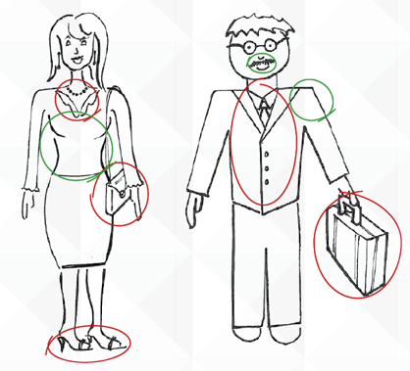*Fig.: sex vs gender drawing*

**Step 2**: Sex and gender as fluid concepts and the complexity of identities (suggested duration 10 minutes)

* The ‘genderbread person’ (below) can help mapping the difference between gender, sex, gender expression, and sexuality.

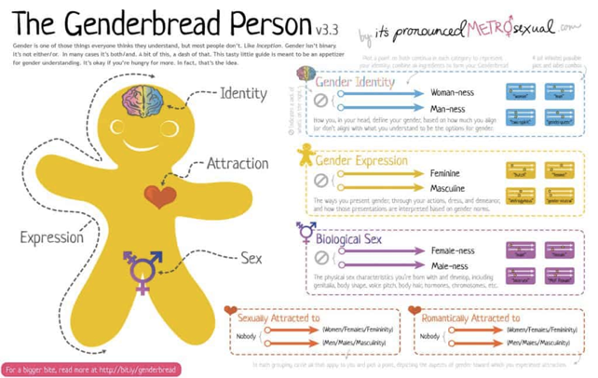

*Fig2: The Genderbread person[11]*

**Step 3**: Intersectionality (suggested duration 20 minutes)

* At this stage, it is important to help participants to reflect about how identities are experienced by individuals than about discrimination.
* Introduce the concept of intersectionality. Each individual is a mosaic of identities: female/male, old/young, rich/poor, married/single, etc. Social research methods analyse simultaneously gender, origin/ethnicity, class, sexuality and other social differences. It is important to note that humanity is composed of men and women (understood as fluid categories) but that people in these two categories are very diverse. A note can also be made about individuals who are biologically intersex or those rejecting those categories altogether and identify as 'non-binary'.

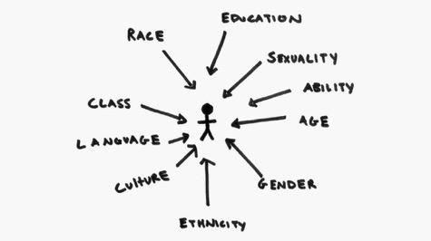

*Elements of identity (Source: https://iwda.org.au/assets/files/intersectionalitystick_ed.jpg)*

* Briefly state that this is important when reflecting on inequalities as people can face discrimination on the grounds of different characteristics (as a woman, as disabled, as a person aged more than 50, etc.) but they can also face inequalities because of a combination of multiple discrimination (e.g. as a black woman).
* The first part of a video See for example, Kimberlé Crenshaw Ted talk, on the urgency of intersectionality available at: <https://www.ted.com/talks/kimberle_crenshaw_the_urgency_of_intersectionality>. This video is available with subtitles in different languages. The 10-13 first minutes in particular can be useful to show.

**Step 4**: Gender norms and inequalities (suggested duration: 30 minutes)

* Organise a buzz session. Ask participants to exchange a story of inequality they have experienced themselves or witnessed in their organization. In plenary, ask each sub-group to present one story.

*Alternative*: if you have a large group of participants, ask them to just exchange in pairs for five minutes on differences they see today between women and men in society. Then ask each group to give one idea that was not mentioned yet and note them on a flip chart.

Point to different aspects in everyday life where inequalities can be experienced: work, family life, decision-making, transport/or mobility, access to services, etc.

* Use this exercise, to explain the relationship between differences and inequalities: the issue is not the difference between men and women as such, but the difference in how attributes, qualities and roles attributed to both genders are perceived and valued. Certain aspects associated with ‘masculinity’ still tend to be valued more highly (e.g. higher pay in traditionally male sectors). It is only when a difference leads to restricted access to resources and to the enjoyment of one's own civic, political and social rights, that it becomes an inequality.   
  Sex and gender are not only the characteristics of an individual, they also form the basis of a system that organises and structures expectations and patterns of interactions between individuals. This system breeds inequality of opportunities, segregation and discrimination. Sexual harassment is rooted in that system.

**Step 5**: Final wrap-up (suggested duration 10 minutes)

* Highlighting the difference between sex and gender, their interaction and the roots of social norms, expected behaviour and attitudes, and inequalities.
* The value of using the concept of gender and intersectionality as an analytical tool of social norms in view of engaging in a comprehensive approach towards ending sexual harassment.

## Activity 2. Inequalities and discrimination

#### Duration: 1,5 hours

#### ☞ Aim

* Developing an understanding of inequality by showing the mechanisms of privilege
* Helping people examine their own privileges
* Promoting a culture of inclusivity

#### ☞ Key aspects

To acknowledge the existence and roots of sexual harassment, it is essential to make the link with gender inequalities. A key aspect to better understand inequalities is to acknowledge privilege, because "privilege is invisible to those who have it"[12]. Privilege and discrimination are the two sides of the same coin: while we are sensitive to situations where we are discriminated against and experience them as injustice, we hardly notice our privilege in other instances.

#### ☞ Target groups

* Middle managers
* Trade union representatives
* Human resources and health and safety officers

**🏱**This sequence can also be useful to train workers in an organization if the goal is not just to raise awareness but to empower them to become active bystanders or upstanders.

#### ☞ Trainer’s preparation

* Prepare the privilege walk: you will need to create different roles (7 to be manageable, each on a different card) and prepare a list of statements (see examples below). Instructions to organise such walk (adapting the questions to the situation) <https://opensource.com/open-organization/17/11/privilege-walk-exercise>.

Such walk is useful when you have a group resistant to recognise unequal opportunities and lacking empathy for discriminated groups. However, as an trainer, you should be aware of the many different implications of the participants depending on their background – some people will have more at stake when they participate and the walk sometimes require people to “come out” as subjected to racism, sexism or other hurtful events in their lives, which can be hard emotional work. As a facilitator you need to be ready to take care of these participants. This can only be performed in “safe” training environment. It could be used in a group where there is a minimum of trust and respect between participants.

* If you are not confident that the exercise can be carried out (e.g. culture of the organization), use a video (e.g. an experience in a college in the USA <https://www.youtube.com/watch?v=4K5fbQ1-zps> or a comic <https://www.boredpanda.com/privilege-explanation-comic-strip-on-a-plate-toby-morris/?utm_source=ecosia&utm_medium=referral&utm_campaign=organic>.
* Prepare a poster using titles referring to types of behaviour and settings (see definition world of work under key definitions) or use the table developed in Module 1, Activity 1 (if that part of the training was performed).

#### ☞ Material

See under Trainer’s preparation.

#### ☞ Proposed sequence and exercises

**Step 1**: Understanding privilege (suggested duration 45 minutes)

* + Present the material explaining what privilege is (see links to video or the comic supra) or organise a walk. Make clear that privilege and inequalities are two related issues and that we can both have to face inequalities while also being in a privileged position. Make the link with the previous discussions on multiple identities and intersectionality (Module 2, Activity 1) that can lead to specific /multiple discrimination.
  + A privilege walk requires at least 7 participants who are all allocated different roles (if more people, they can be observers to limit the preparation). Cards with assigned roles should be prepared in advance and distributed to participants. All 7 participants are asked to stand next in line. Each is handed a card with a prescribed role. They read it for themselves then out loud for the rest of the group. The facilitator then reads out statements, and they have to either step forward or backward according to their role.

Examples of roles:

* Man (38): you are recently divorced and have alternative custody of your kids. You have always been motivated by your job and are used not to be too involved in caring issues. So, this new life is complicated for you. You are also under financial pressure now and would like to get promoted soon.
* Woman (28): you have been recently hired and this job corresponds to what you really want to do. You are aware that you need to travel and work long hours. You are a bit concerned about your private life as you have started a serious relationship.
* Man (57): you are one of the managers of the organization. You have been in a relationship with a male partner for years now, but you want to keep your private life secret.
* Woman (38): you have just been hired on a fixed-term contract (for the duration of a project). You really would like to stand out in the group of 10 newly recruited personnel and get a fixed-term contract.
* Woman (48): you have been single your entire life. Since an accident at the age of 18, you have been in a wheelchair. The settings in the office are ideal for you (elevator, large space, etc.). However, it still remains difficult to go everywhere and the commute from homework is problematic.
* Add more profiles if needed …..

Examples of statements:

* One of your children gets sick at school. Take a step forward if you are not the one called in or if you can count on someone else to pick up the child. Take a step back if you need to leave work and pick up the child.
* There is an unplanned meeting in the office outside of normal working hours. If you stay for it take a step forward. If you cannot because of transportation or care issues, take a step backward.
* The company is starting a cycle club to reinforce links between members of the personnel. They recommend a good electric bike to be able to follow the group. The plan is to do such bike trips on weekends. Take a step forward if you can participate. Take a step back if you cannot afford such a bike and do not have time (or are under any other constraints) to go cycling. Stay where you are if you cannot afford the bike or do not have time for it.
* Your colleagues look at you as an expert, a true leader and frequently come to you for advice on different issues. Take a step forward if this is the case. Take a step backward if this is hardly ever the case.
* An internal promotion round is coming up in your organization and you have good chances of being promoted. This will mean that you will have to travel extensively with your boss who uses sexist language and has made suggestive (sexual) comments to you. Take a step forward if you think that this will not be a problem. Take a step back if you do not see how such situations can be handled.
* If you can show affection for your romantic partner in public without fear of ridicule or violence, take one step forward.
* Add more statements if needed….

After the exercise, ask participants:

* What did it feel like being in the front of the group? at the back? in the middle?
* Which factors influencing your position or your privilege had you never thought about before?
* What statement made you think most?

**Step 2**: Workplace organization and structure (suggested duration 30 minutes)

* Display the poster with identified inappropriate behaviours.
* Ask participants to reflect on the social norms within their own organization and power relations in the organization: which elements mitigate risks of inappropriate behaviours in the workplace (e.g. horizontal hierarchy, management style, women in key decision-making positions, training of personnel / new-comers, gender equality plan, etc.)
* Present data, studies on current inequalities and discrimination in the organization or in relatable sector (horizontal and vertical segregation, decision-making, type of contracts, working schedules, working conditions, pay, etc.).

**Step 3**: Wrap-up (suggested time 15 minutes)

* On the reality of privilege that we are generally not aware of and its impact.
* How deeply rooted inequalities are in the workplace and how they link with sexual harassment.

# Module 3 – Comprehensive prevention activities in the workplace: base line analysis

#### Duration: 3 hours

#### ☞ Learning objectives:

* Identifying actors to be involved directly and indirectly in designing and implementing such policy.
* Collecting the information needed to carry out a risk analysis of sexual harassment.
* Identifying windows of opportunities for developing/improving a comprehensive policy/strategy.

#### ☞ Aim

This module focuses on examining elements needed to be able to design an effective prevention policy. This means:

* to identify who are the actors (to be) involved,
* to reflect on the issues at stake (gathering information on sexual harassment and occupational safety and health risks in particular),
* to review current prevention measures and procedures.

#### ☞ Key aspects

A comprehensive prevention policy presupposes to identify hazards and risks of sexual harassment. This requires consultation with workers and their representatives and collecting information on the occurrence, reality of sexual harassment within the organisation.

Different techniques can be used to collect data and assess risks: administrative data, interviews, focus groups, questionnaires, workshops, observation (ethnography), etc.

Additionally, examining occupational safety and health risk management procedures existing in an organisation or prevalent in the sector needs to be part of the data collection.

Involvement of stakeholders is an important step to develop and implement a comprehensive prevention strategy: they can provide information on the issues at stake and support change. A group of change agents[13] can be identified from the consultation with stakeholders as well as a core group in charge of implementing the policy.

The policy should always be integrated and coordinate gender/diversity equality, health and safety or any other plans depending of the national context (legal framework) and the organization’s culture and history (e.g. windows of opportunities if a gender plan already exists, or if internal regulations are reviewed, etc.). As the prevention of sexual harassment must be part of systemic, integrated and long-term approaches addressing prevention, protection and prosecution and the conditions that guarantee an integrated and coordinated approach should be clearly identified and acted upon.

#### ☞ Target groups

* Representative of women workers if any.
* Trade union representatives.
* All management levels.
* Equality, HR and safety officers.
* Change agents.

#### ☞ Trainer’s preparation

* Identify the wider context in which the training workshop will take place: process review or set up, implementation of a new regulation (legal or collective agreement), request from the hierarchy, etc.
* Check with the organization what measures and processes regarding sexual harassment are currently in place and how they are framed (systemic or not, health and safety, gender equality, etc.)
* Get information on both the existing gender equality/diversity policies and health and safety policies.

#### ☞ Material

* Cards (post-it type) of different colours.
* Brown paper, poster or pin boards.
* Tape to fix the cards (or pins).
* Black markers type Artline 70 (one for each participant).
* Flip chart paper.
* Colour markers for trainer (black, blue, red, green).
* Poster for stakeholder mapping.
* Poster for the SWOT Analysis.
* Laptop/computer and a beamer.

#### ☞ Proposed sequence and exercises

**Step 1**: Identifying stakeholders (suggested duration 60 minutes)

* To get started in developing or revising an action plan or strategy to prevent sexual harassment in the workplace, it is key to first identify who needs to be involved in a broad sense to collect information or to implement the strategy.
* Divide participants in sub-groups (4-5) and distribute cards. Ask them first to identify all possible stakeholders, noting one per card. Ask them to think out of the box: people from the organization (human resource manager, trade-union representatives…) but also outside (external experts, representatives of an association, …); typical (e.g. trade unions) or more atypical (e.g., women organizations, researchers); to be involved during the entire process (health and safety responsible person) or at a certain point (e.g. top manager).
* Give each of the subgroups an empty stakeholder map. Ask participants to place their stakeholders according to power in relation to sexual harassment issue and interest (sympathetic to the subject).
* Ask participants to present their results in plenary highlighting differences in their mapping.
* Explain to participants that the stakeholder map is useful to identify key players. These are the one with high power and high interest in sexual harassment/gender equality. Example of a stakeholder map that you can use for a slide to show the different level of involvement.

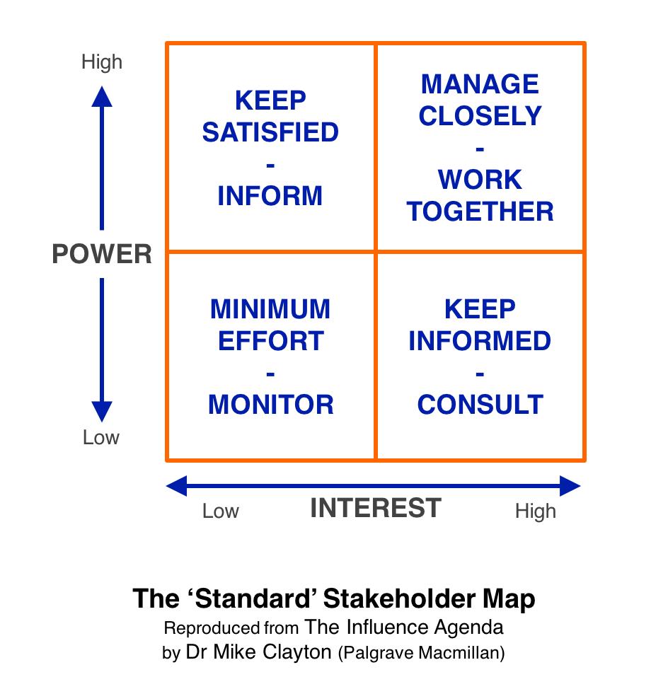

Source: https://onlinepmcourses.com/wp-content/uploads/2017/07/Standard-Stakeholder-Map.png

* Agree on key players.
* It can be relevant to ask also participants to identify a core team of change agent to be involved in the process of designing and implementing the prevention strategy.

**Step 2**: Identification of risk factors of sexual harassment (suggested duration 40 minutes)

* Organise a buzz session on factors that increase the likelihood of violence and harassment. See toolkit section on carrying out a workplace risk assessment (pages 29-30)
* Indicate to participants that they should reflect on the potential risks of sexual harassment in three main areas:
* From working conditions and arrangements, work organisation and human resource management as appropriate
* Third parties such as clients, customers, service providers, users, patients and members of the public and
* Discrimination, abuse of power relations, and gender, cultural and social norms that support violence and harassment.
* Collect ideas on a flip chart and classify them according to the three main areas.

**Step 3**: assess base-line information available on occurrence and risk factors of sexual harassment (suggested duration 45 minutes)

* In plenary ask participants what information they currently have on sexual harassment in their organization. Note the type of information on a flip chart (e.g. number of cases, sex of author and victim, role/function of author, etc.) in one column.
* Ask them what other info is needed to develop a comprehensive prevention policy?
* Ask participants in plenary to complete the table on how/where they can get the information needed to design/develop their policy.

|  |  |  |
| --- | --- | --- |
|  | Information needed | How/where to get it? |
| Information we have already | - number of complaints  - number of incidents in year  - risk factors relating to third parties…. | - administrative data  - survey done in year x+1. |
| Information we need | - location of incident  - characteristics of victims (e.g., type of contract)  - risk factors relating to working conditions: crossing information on incident and work organisation, etc  - risk factors relating to discrimination and abuse of power: crossing information relating to profile of author and incident. | - administrative data through an additional field  - survey by trade unions …….  - consult women workers |

**Step 4:** identify current strengths and windows of opportunities for developing a strategy in their organization/ sector (suggested duration 60 minutes)

* Present briefly elements of comprehensive prevention activities in the workplace to participants (see Toolkit section 3, page 26-33) to trigger the SWOT analysis:
  + Working on changing the culture of the organisation
  + Implementing prevention through occupational safety and health risk assessments
  + Engagement of the employer to take responsibility for preventing sexual harassment
  + Existence of sexual harassment prevention measures in occupational safety and health
  + Workplace risk assessment carried-out
  + Existence of a comprehensive gender-responsive prevention strategy in the workplace
  + Existing monitoring and enforcement mechanisms
  + Gender-responsive labour inspection
* Divide participants in sub-groups. Ask them to brainstorm on strengths, weaknesses, opportunities and threat (SWOT Analysis) reflecting on elements presented of comprehensive prevention activities.

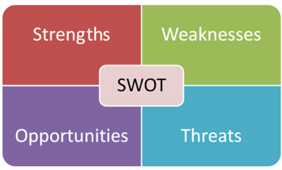

* In plenary, each sub-group presents its results.
* Get agreement from participants on strengths and window of opportunities for possible activities/action plan.

**Step 5**: wrap up (suggested duration 10 minutes)

* On key players to be involved and potential change agents.
* On additional information needed to develop a comprehensive strategy.
* On presence of a window of opportunities if any and on strengths.

# Module 4 – Workplace policies, procedures and practices

#### Duration: 4 hours

#### ☞ Learning objectives

* Clarify what are the main elements of a workplace policy.
* Be able to audit the current workplace policies
* Learn to develop an action plan

#### ☞ Aim

* Identify what elements exists and are applied currently in their workplace policies, procedures and practices.
* Identify missing elements and potential actions for improving workplace policies.

#### ☞ Key aspects

In terms of process, workplace policies and procedures to be effective should be embedded in human resources management and social dialogue with procedure that are trusted by workers. Workplace policies should be monitored and evaluated regularly to see if adaptations are needed. Effective workplace policies and procedures should be embedded in human resources management processes and social dialogue.

In terms of content, ILO Convention No. 190 requires that governments put a duty on employers to draw up a workplace policy. The accompanying ILO Recommendation no. 260 suggests elements to be included in the policy (see items under trainer’s preparation).

Policies in the workplace should clearly describe conduct and behaviour that are unacceptable in the workplace, be accessible (in terms of language and accessibility).

#### ☞ Target groups

* Representative of women workers if any.
* Trade Union representatives.
* All management levels.
* Equality/Human resources and health and safety officers.

#### ☞ Trainer’s preparations

* See ILO Recommendation no. 260 that provides that a comprehensive workplace policy should include the following elements:
* State that the violence and harassment will not be tolerated
* Establish violence and harassment prevention programmes with measures objectives
* Specify the rights and responsibilities of the workers and employers
* Contain information on complaint and investigation procedures
* Provide that all internal and external communication related incidents of violence and harassment will be duly considered, and acted upon as appropriate
* Specify the right to privacy of individuals and confidentiality while balancing the right of workers to be made aware of all hazards and include measures to protect complainants, victims, witnesses and whistle-blowers against victimization or retaliation.
* Prepare a flip chart with the audit tool (step 2).

#### ☞ Material

* Cards (post-it type).
* Brown paper, poster or pin boards.
* Tape to fix the cards (or pins).
* Black markers type Artline 70 (one for each participant).
* Flip chart paper.
* Colour markers for trainer (black, blue, red, green).
* Laptop/computer and a beamer.

#### ☞ Proposed sequence and exercises

**Step 1**: Presentation of what effective workplace policies should contain (suggested duration 30 minutes)

* Ask participants to brainstorm of what an effective workplace policy should comprise. Give them cards to write their ideas. Prompt: what could or should be covered in a workplace policy?
* Collect cards and discuss with participants how they can be organised around similar themes. Add a title to each of these clusters. To facilitate the discussion on clustering cards you can use the elements of the ILO Recommendation or of the audit tool (infra).

**Step 2**: Current state: audit tool (suggest duration 20 minutes)

* What is contained in our current policy? Ask participants to reflect on the following table and identify where some policies have been adopted, or not and what are the areas to work on. This last aspect should be just a broad indication of what is needed as this will be further discuss in step 4.

|  |  |  |  |
| --- | --- | --- | --- |
| Items | Yes | No | Areas to work on |
| 1.Workplace policy for protection against gender-based violence and harassment, including complaints procedures that are trusted and effective. |  |  |  |
| 2. Prevention of gender-based violence and harassment, including risk assessment and measures to mitigate risks. |  |  |  |
| 3. Awareness raising in the workplace and training of managers and bystanders. |  |  |  |
| 4. Support for victims of gender-based violence and harassment. |  |  |  |
| 5. Measures to hold perpetrators accountable. |  |  |  |

**Step 3**: what works well? (suggested duration 90 minutes)

* Divide the group in sub-groups (ideally per 4 or at least even number if possible). Ask each sub-group to deal with one aspect of the audit tool where they have indicated a yes. If one aspect has received a No in the audit tool, check that there is really no one that can exchange positive stories on this.
* Ask them to exchange stories on what works well and how it was adopted. Give the following instruction: focus on things that works; a story is a narrative so there should be an introduction, then presenting some problems that emerge and a conclusion, a solution found.
* The first group will exchange stories on what works well in terms of workplace policy including complaint procedures so for example will present a story on how the policy was adopted or how they make sure that the procedures are trusted by workers, the second on stories about prevention including risk assessment, the third one on awareness raising and training, and so on.
* Attention: within each sub-group, there are different rounds of exchanges. First an exchange 2 by 2: each person tells a story and the other asks questions, trying to develop an argument why it worked well, to extract helpful factors in solving the problem. These positive elements are written on a card.
* In a second round, one pair exchange with another pair of the same subgroup. Each pair chooses one of the stories. One member of each pair summarises the story chosen and explains the positive elements on the cards.
* In plenary, cards are displayed on a poster (brown paper). As a trainer, see if positive elements can be clustered. The advantage of this exercise before getting to step 2 relating to planning, is that it will help the group to focus on possible solutions and not on problems.

**Step 4**: how to improve your workplace policy? (suggested duration 90 minutes)

* Go back to the audit tool and ask participants to gather in sub-groups. The allocation of participants in groups is depending on aspects they have identified as “areas to work on”.
* Ask participants to identify 3 aspects that need urgent addressing (each group is working on one item of the workplace policy).
* Share in plenary.
* Invite each sub-group to work on **one aspect** and identify what is the goal (e.g., raise awareness of the employees, appoint a person responsible for complaint, get an official engagement from the top management, etc), who should be involved, who is responsible, a budget that can be used, and a possible timeline.

|  |  |  |  |  |  |
| --- | --- | --- | --- | --- | --- |
| What | Goal | Actors (to be involved or target of actions | Responsible person | Budget | Timeline |
| Organise a training on SH | Raise awareness of employees | Human resources  Training department  Decision-maker  All employees | XX | Line  ….euros | To be organised by… |
| Adopt a code of conduct | Clarify procedures both formal and informal to investigate and handle complaints of SH | Manager  Trade union representative  Gender equality officer  Health and safety officer | XX | None | To be adopted within |

* Share in plenary the results of the working groups.

**🏱**the following two sequences can also be useful if the training takes place in one organization as it gives impetus to participants to start acting concretely.

* Ask all participants to indicate/vote for one (or more depending on number of groups and objectives of the training) action to be implemented directly.
* If time allows, and if relevant to the goal of the training, ask participants to work on concrete steps for this chosen action.

|  |  |  |  |  |  |  |
| --- | --- | --- | --- | --- | --- | --- |
| What | Goal | Actors (to be involved or target of actions | Steps/  Actions | Responsible person | Budget | Timeline |

# Module 5: Effective complaints procedures centred on support of victims

#### Duration: 4 hours

#### ☞ Learning objectives

* Review existing formal and informal procedures from a victim support viewpoint.
* Understand how existing procedures support victims and whether they must be adapted.

#### ☞ Aim

* Get a common vision on how victims are currently supported
* Get ideas of possible solutions to improve existing process and procedures

#### ☞ Key aspects

Sexual harassment remains a taboo subject. Victims do not talk and do not report cases because they fear that there will be negative consequences for them which is compounded by the difficulties of proving sexual harassment. Effective formal and informal procedures should be in place. A variety of routes to report sexual harassment should be available. Procedures in place should ensure protection of the victims, respects of the rights of the authors. In the longer term, effective procedures will have an impact on reducing incident of sexual harassment even though it should be made clear that an absence of complaints is not necessarily a sign of absence of incidents.

#### ☞ Target group

* Representative of workers (to get people from the organization motivated).
* Trade Union representatives.
* Middle managers or representatives of the employer.
* Equality/Human resources and health and safety officers.

#### ☞ Trainer’s preparation

* Prepare an example of a persona (see example infra).
* Optional: prepare a story
* For the journey map, you may consult: <https://www.atlassian.com/team-playbook/plays/customer-journey-mapping> or <http://ixd.prattsi.org/2019/11/user-journey-mapping/>
* About the lotus blossom techniques, see <https://thoughtegg.com/lotus-blossom-creative-technique/> or <https://andyeklund.com/brainstorm-technique-lotus-blossom/>

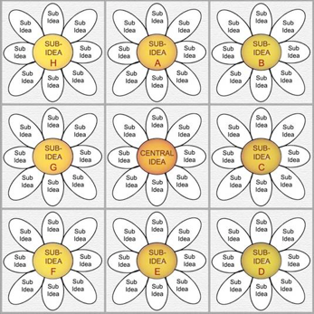

#### ☞ Material

* Cards (post-it type) of different colours.
* Brown paper, poster or pin boards.
* Tape to fix the cards (or pins).
* Black markers type Artline 70 (one for each participant).
* Flip chart paper.
* Colour markers for trainer (black, blue, red, green).
* Persona cards (images of persona: take images on the internet representing persons corresponding to reality of your sector. Make sure to have image of people in their diversity).
* Poster for lotus blossom.
* Laptop/computer and a beamer.

#### ☞ Proposed sequence and exercises

**Step 1**: developing a persona (suggested duration 60 minutes)

* The facilitator shows the example of Lisa and tells her story.

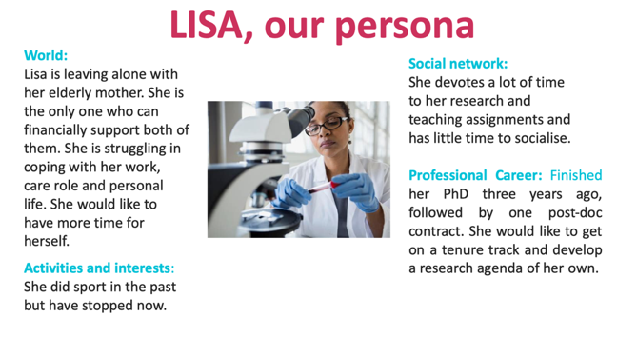

**HER story**: Lisa is attending team meetings every month. She is the youngest member of the team. Her line manager, a married man, is prone to unnecessary close physical proximity and sexually explicit ‘jokes’. During the last meeting as she expressed uncertainty about one aspect discussed, her line manager said that as they were leaving the following day for a two-day conference abroad, she should come to his bedroom to get all necessary clarifications.

* Ask participants to develop such a persona (highlighting some elements relating to relationship, community (activities and network) and professional situation. Ask participants to create a persona and think of a story and a short story of sexual harassment they can encounter.
* Give the following instruction: based on the example of Lisa, develop in subgroup a persona. In doing so, think about a person, she or he, that will be particularly vulnerable if confronted to sexual harassment (e.g. typically NOT the CEO of the company). Such exercise of developing a persona in sub-group is important to help the participant to identify vulnerable people and then work (journey map, next step), whether the process in place are supporting such victims.

**🏱**This activity helps participants to think about different types of profiles of people who can suffer from sexual harassment because of elements relating to their working conditions and professional position (e.g. shift work, contact with clients, type of contract; waiting for a promotion, etc) or elements of their personal life.

**Step 2**: What is there to help Lisa? What is missing? (suggested duration 90 minutes)

* The journey map method can be used here. It is a powerful method that put the “client”, here the victim, at the centre of the process, while generally training focus on institutional perspective and logic. So, the exercise is about looking at the journey a victim follows, identify contact points with the institution, and how they can be improved to better meet the need of the victim.
* Based on the persona and story developed, ask participants in sub-groups to reflect on the experience of the persona (e.g. Lisa). What will she do or look for? What are the steps she would be likely to take or instead refuses to take? Reflect on the different steps of current process (formal and informal)[14] and critical aspects from Lisa’s perspective. The complete journey needs to be mapped.
* Ask participants to first map all steps in the process, secondly to identify all points of interaction between the victim and the institution and put them on a timeline. The instructions to the group are the following for these steps and should be put on a slide:
  + First map all the steps in the process (write on the top of the poster presented below)
  + Secondly identify the contact point between the employee/victim and the institution and put them on the timeline.
  + Third identify the points (touchpoints) that are critical from a perspective of fighting sexual harassment.
* Results: the group maps out all the steps before a victim comes in relation with the organization service to victims of sexual harassment (e.g., all actions taken to make sure that people in the organization know about the policy, what to do etc. Then map what the service provided to the victim during the intervention and finally map steps of what is in place to continue to support the victim after the intervention. Identify the points of interaction between the victim and the institution (a colleague, a contact point, a representative from trade-union, a department.) and how this can be done (direct contact, e-mail, suggestion box,). These are put in the chronological line. Second, the group identifies the most critical points of interaction.

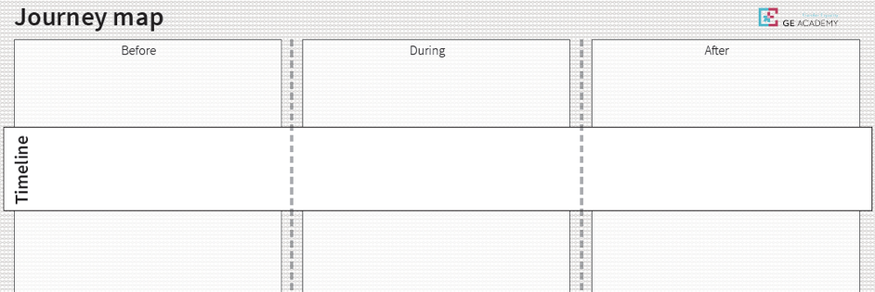

Source: Yellow Window and the GE Academy[15].

* Each working group presents in plenary its journey map and highlights what is going well and the critical points on which to act. (suggested duration: 30 minutes).

**Step 3** : possible improvements (suggested duration: 60 minutes)

* Following the work done with the journey map, identify possible solutions for one of the critical aspects(s) identified (use of the lotus blossom technique). Possible issues to tackle are how to get on board people from all levels of decision-making, how to handle complaints; how to protect the victims; how to avoid confrontation between victims and perpetrators. The lotus blossom technique is interesting to use as it helps to focus on one central problem and possible solutions. Then this first set of solutions are in turn becoming central problems.

# Module 6: Active bystanders approaches

#### Duration: 2 to 3 hours

#### ☞ Learning objectives

* Understand that each person has a role to play to counter sexual harassment at work.
* Understand that to reduce risks of sexual harassment, each behaviour, even perceived as minor by the bystander, should be acted upon.
* Get tips on possible ways to act.

#### ☞ Aim

* Get all staff actively involved in preventing/stopping sexual harassment.
* Let people express their ideas on ways to act but also explore possible fears.

#### ☞ Key aspects

Someone who witnesses sexism, sexual harassment or any forms of bullying, either in person or online, is a bystander. An upstander (or active bystander) is someone who takes an active role to prevent and end sexual harassment by deciding to intervene when they witness inappropriate language, jokes or other sexually harassing conduct in the workplace.

Becoming an active bystander who can intervene to end sexual harassment requires that a worker is trained, supported and encouraged to notice the signs of sexual harassment and intervene to stop it. As a result, active bystanders can play an important role in intervening to prevent sexual harassment and supporting the person who is being targeted with sexual harassment in the workplace. Training can help to empower work colleagues to intervene to prevent violence and harassment from occurring. Building skills to be active bystanders helps employees to recognize violence and harassment and to know when it is appropriate and safe to intervene.

A key element to enhance active bystanders is to ensure protection for workers who support victims. The concept of second order sexual harassment (SOSH) recognizes that supporters may also face retaliation and experience victimisation when they offer support to colleagues experiencing sexual harassment. SOSH is sexual harassment that is perpetrated against a person who gives support to a victims/survivors of sexual harassment. This acts as a powerful way to keep supporters, bystanders and witnesses silent in the workplace. Therefore, SOSH needs to be recognized and named to tackle the issue.

Within research organization, students, peers, teachers, academic staff, parents, and other youth-serving adults can be bystanders. With cyberbullying, even strangers can be bystanders. It is important to be attentive to even the slightest form of sexual harassment because it has the potential to open the door to more severe behaviour.

#### ☞ Target group

* All staff members.
* Representative of workers (to get people from the organization motivated).
* Trade Union representatives.
* Middle managers or representatives of the employer.
* Equality/Human resources and health and safety officers.

**🏱**for this module, it is particularly important to get a balanced participation of men and women and having top managers participating.

#### ☞ Trainer’s preparation

* Prepare a script of a “real case” of sexual harassment.
* Prepare a slide on the purpose of the bystanders’ intervention, it’s limitation as well as risks.

#### ☞ Material

* A4 paper with the scenario (one for each participants).
* Tape to fix the cards (or pins).
* Colour markers type Artline 70 for (one for each participant).
* Flip chart paper.
* Colour markers for trainer (black, blue, red, green).
* Laptop/computer and a beamer.

The sequence should draw on the experience of participants and develop ideas on how to act to support each other. It should also give participants room to express their fears. It is important to have men in the room, in particular from higher positions that support such training.

**🏱**If this is a stand-alone training, it should start with a session on what is an inappropriate behaviour (different types, localisation etc). See module 1. Suggested duration for that activity is one hour.

#### ☞ Proposed sequence and exercises

Step 1: Role play (suggested time 40 minutes)

* Divide participants into sub-groups of 5 people.
* Ask participants to think about a short scenario of sexual harassment. You can also provide a short script. For inspiration, see for example, Period Guide, It’s not that grey[16].
* Ask each group to agree on two participants that will “play” the situation involving an inappropriate behaviour. The other participants have to imagine that they are active bystanders. How would they (safely) act (direct intervention or other safe ways to act)?
* After the role play, each sub-group share ideas on how to safely act should be put on a flip chart.
* Ask the group to re-play that situation and to integrate advice on safe active bystanders interventions. (this can also be done in plenary by each group if times allow).
* Ask participants to reflect on fears/difficulties to be an active bystander.

**Step 2**: Share in plenary. (suggested time 30 minutes)

* Each group points to ideas on how to safely act and what fears and difficulties to be an active bystander they have discussed.

**Step 3**: monitoring and reporting (15 minutes)

* Ask participants to reflect on how to involve the hierarchy and how to document (reporting system) such interventions (as these may later be needed for evidence).

**Step 4**: wrap up (30 minutes)

* Show slides to add/wrap up ideas on how an active bystander can act, limits of bystanders’ intervention, when to stand back, etc. Use the UN example of menu of bystander intervention or any example you know that may be relevant.

A menu of bystander interventions

**Support** – being in contact with the target of sexual harassment, including at a later time. Ask how they are, if they want support, someone to talk to. Refer to pages 29-30 in this publication for guidance on such conversations.

**Delegation** – engage other people in a response. In a workplace this might be informing a supervisor or other colleague; in a university other students or staff can be approached to step in or in other ways offer support or sanction.

**Distance** – being in contact with the harassed person at a later time for example to check on how they are, share resources. Likewise, if judging it to be safe, the harasser can be approached at later time, for example to express concern at what happened.

**Document** – having a record of an incident is always helpful in monitoring the culture and behaviour in an organization. It can also support any report that might follow. Those who are caught up in such an event may not have the time or ability to make a record at the time so any form of documentation (including photographs, screen grabs) may be useful. Ensure victim-survivor permission for any visual record.

**Distraction** – speaking or acting so as to draw attention to something else. It can diffuse an incident through, for example, dropping papers, spilling a drink, walking between the abuser and the victim-survivor.

**Direct interventions** – an approach to the perpetrator can involve, for example, a very short and clear statement such as ‘I’m uncomfortable with what you are doing’. This can be difficult especially if a junior person is witness to prohibited behaviour by a senior person, with a risk of escalation or being targeted, so should not be undertaken lightly. It can be received as confrontation or insubordination.

**Source** : UN Women (2019) What will it take? Promoting cultural change to end sexual harassment. New York, UN Women. Available at: UN Women, https://www.unwomen.org/-/media/headquarters/attachments/sections/library/publications/2019/discussion-paper-what-will-it-take-promoting-cultural-change-to-end-sexual-harassment-en.pdf?la=en&vs=1714

* Ask participants if they feel more confident on how to be active bystander after the session.

# Practicalities - designing a training course on how to prevent and handle sexual harassment in the world of work

## 1. Conditions for an effective training

* Support at the highest level, for example asking the direction of the organisation to come to welcome the participants and emphasis on the importance of the training.
* Link with gender equality policy/plan. A training is always part of a broader context. It is important to ensure that the training is positioned within existing gender equality policies.
* Ensure that participants learn ways to prevent and act upon sexual harassment by understanding what is achievable and relevant to their roles and responsibilities.
* Ensure that the quality and rigor of the training through evidence-based information.

## 2. Define your target group:

The way you will organise your training or awareness raising event depends on the profile of the target group:

* The workforce in general: important to see if you have to organise it for certain groups
* Human resources/GE/diversity officers
* The management level, decision-makers
* Health and safety personnel or people involved in the process of combatting SH
* Social partners
* Trade unions

Try to get a balance participation of men and women in the training to avoid that sexual harassment is seen as a “women’s issue”.

## 3. Framing your training:

It is important to assess the target group's level of familiarity with the issue (basic or advanced training) and how to frame the training course to ensure high take-up rate.

Define the type of training according to the participants' knowledge: basic or advanced (previous knowledge on the subject or having a dedicated function, e.g., health and safety responsible person).

Framing the training: ensure that people will be attracted by the training, that they will see benefits for themselves. What are the interests of the participant targeted by the training? Adapt content according to the target group and culture of the organization: name of the training to attract participants and decide about the duration of the training.

## 4. Learning objectives:

Should be clearly defined and realistic in view of the targeted audience, duration and methodology.

Traditionally, you can have three different types of approaches to training:

* To increase awareness about impact of sexual harassment (for everyone);
* To build skills and knowledge for managers (e.g. prevention, risk assessment, workplace policies, complaints procedures);
* To encourage bystanders in the workplace (employees).

Possible learning objectives:

* Understanding what SH is and its impact on the organization and individuals affected. Evidence based.
* Getting all actors on board in the organization, ensuring support for a strategy or an action plan to be designed and implemented.
* How to prevent sexual harassment? Defining a prevention strategy and a process to handle cases.
* Position SH in a wider spectrum of gender inequalities and in the social norms existing in a specific organizational environment.
* Bystanders approach: all people understand that they have a role to play and know how to act.
* Add any other relevant learning objective.

## 5. Methodology of the training and set-up

* Use participatory techniques as much as possible to ensure a share of power and knowledge in the group.
* Be clear when designing your training that it fits learning objectives
* Ensure that the training is adapted to the target group of the training in terms of duration, location and content. For example, training with line managers can be organised through regular short sessions instead of a full two days.

## 6. Duration/format:

Adapt the format and duration to different target groups and learning objectives.

* Face to face training course: up to 2 days. Allows to address the topic substantively, from understanding the issue to developing a clear idea of what can/should be done and how. Can combine presentations with interactive sessions.
* Workshops: up to a day, to train participants in small groups on a specific issue where interactivity is central. Can be integrated in an existing training session, for example, for newcomers.
* Webinars: from 1.00 to 3 hours. Introduction to the issue. Can serve to “attract” people for a future training or workshop. Can also be used to present a series of practices (up to 3) with a Q&A session[17].

## 7. Drafting a training script and preparing material

* A script should clarify what are the learning objectives, groups/profiles targeted by the training and precise sequence of the training.

Proposed model to draft a script

|  |  |  |  |  |
| --- | --- | --- | --- | --- |
| Time for the programme | Title for the programme | Methodological approach | Time for each sequence | Observation/  material |
|  |  |  |  |  |
|  |  |  |  |  |
|  |  |  |  |  |
|  |  |  |  |  |

## 8. Evaluating the training

* Ex-ante: get a better understanding of expectations and existing knowledge of participants.
* Exit (at the end of the training): check that learning objectives have been met.
* Ex-post (after 6 months): what is the real effect of the training? Possible next steps/needs/training course?

Example of content of questionnaire

|  |  |  |  |
| --- | --- | --- | --- |
|  | Ex-ante | Exit | Ex-post |
| Personnel identification features, such as gender, nationality, type of organization, employment position, etc. | x | x | x |
| What do you expect to learn from this training/session?  Multiple choices with regards to learning objectives of your session | x |  |  |
| Did you learn what you expected during this training/session |  | x | x |
| Have you already some knowledge of the issue.  Multiple choice: formal education, training, on the spot knowledge, etc. | x | X (had you) | X (had you) |
| Are you satisfied with the training?  Multiple choice: relevance for your work, content, method |  | x | x |
| Can you apply some of the learning in your work? |  | x | X (Have you) |
| Are you satisfied with the trainer?  Multiple choice: knowledge, communication/training skills, gender sensitive language/communication; methods |  | x |  |
| Did the training provide you?I  Multiple choice: space to interact; reflect on your own practice; useful knowledge. Identify possible changes (due to training) in your perception regarding sexual harassment |  | x |  |

# Annexe – list of useful information to gather

page20image35349024**Where are we in my organisation to address sexual harassment?**

Context

* European, National or Regional **legislation** applicable (reference and link to access the text).
* Current national, regional or local **policy** applicable (reference and link to access the text).

Definition

* What is the definition of sexual harassment at work used in the organisation?

Occurrence of sexual harassment

* Do I have quantitative data on sexual harassment that I can use?
* Is there any qualitative information available (e.g. survey? …)

Does my organisation have a gender equality plan or any measurement to gender equality?

* Main objectives
* Main measures planned
* Is sexual harassment or other forms of violence covered?
* Is gender equality monitored and evaluated? Internally and / or externally? How often?
* Is sexual harassment part of it ?

Who are the main actors involved in my strategy/plan directly and indirectly (in design and implementation, especially) relating to sexual harassment?

Main aspects of the organization’s policy in terms of :

* primary prevention: stop violence before it begins through awareness and changing the workplace culture
* secondary prevention through training and awareness raising
* tertiary prevention through effective human resource policies and complaint procedures

Any factors of risks identified?

What is the procedure for complaints?

Is there Informal procedure for complaints?

Main problems identified in terms of complaint procedures (e.g., no complain).



1. This does not mean that we don’t recognise that these categories are more fluid and not so binary. See Module 2, activity 1.
2. In this handbook, the total duration of a sequence doesn’t not necessary correspong to a strict addition of time allocated to each activity. This is explained that the duration is an estimation of the time needed to conduct the proposed sequence but i twill vary according to for example, number of participants.
3. This should be understood as covering any type of behaviour beyond sexual demand which is an expression of gender inequalities and sexist behaviours.
4. See Toolkit, p4.
5. See for example a list of types of sexual harassment at https://workplacerightslaw.com/library/harassment/forms-of-sexual-harassment/ . Or section 2 of the guidelines for the prevention of sexual harassment, harassment on grounds of sex and psychological harassment of the Polytechnic University of Madrid (UPM) available at https://triggerprojectupm.files.wordpress.com/2014/10/guia_acosodiscriminacion20150428_review_eng.pdf
6. In a buzz session, small sub-groups of two to four persons exchange ideas on a topic proposed by the trainer during a short period (2 to 5 minutes).
7. The idea is to assess the knowledge and practice of participants of existing procedures. It is not about being right or wrong. It provides useful information for the training relating to Module 5 on existing procedures and support for victims.
8. This classification is in fact a simplification as any individual can have biological masculine and feminine features. The issue of intersex will also have to be briefly explain and so it is worth checking before the session the legal regulation about attribution of a biological sex at birth.
9. *On ne naît pas femme, on le devient*, the frequently quoted title of Simone de Beauvoir's book, also applies to men.
10. In a buzz session, small sub-groups of two to four persons exchange ideas on a topic proposed by the trainer during a short period (2 to 5 minutes).
11. See useful resources to explain this at https://www.genderbread.org
12. Quotes from Michael Kimmel, see at <https://www.theguardian.com/sustainable-business/2016/jun/08/workplace-gender-equality-invisible-privilege>.
13. Lunenburg, Fred, (2010), Managing change: the role of change agents, *International Journal of Management, Business and Administration*, Volume 13, Number 1. A change agent is the individual or group that undertakes the task of initiating and managing change in an organisation. Change agents can be internal, such as managers or employees who are appointed to oversee the change process. In many innovative-driven companies, managers and employees alike are being trained to develop the needed skills to oversee change.

    https://naaee.org/sites/default/files/lunenburg_fred_c._managing_change_the_role_of_change_agent_ijmba_v13_n1_2010.pdf
14. See For more on formal and informal procedures, see Toolkit pp 38-39.
15. Project « SwafS-13-2018 Gender Equality Academy and dissemination of gender knowledge across Europe » financed by Horizon 2020 research and innovation programme under grant agreement n°824585. See website <https://ge-academy.eu>.
16. Period.Brussels (2019), It’s not that grey. How to identify the grey area - a practical guide for the twilight zone of sexual harassment, pg 18 and following, available at <https://periodbrussels.eu/wp-content/uploads/2019/04/Its-not-that-Grey_Period_Guide_2019_online.pdf>.
17. See the Virtual Dialogue organised by UN Women on « Online Methodologies and Training for Gender Equality » (22 July 2020), available at <https://www.youtube.com/watch?v=W3ljKYyW5iM>.